- Verify that clicking on the footer icon does not redirect the user to the relevant section of the homepage.

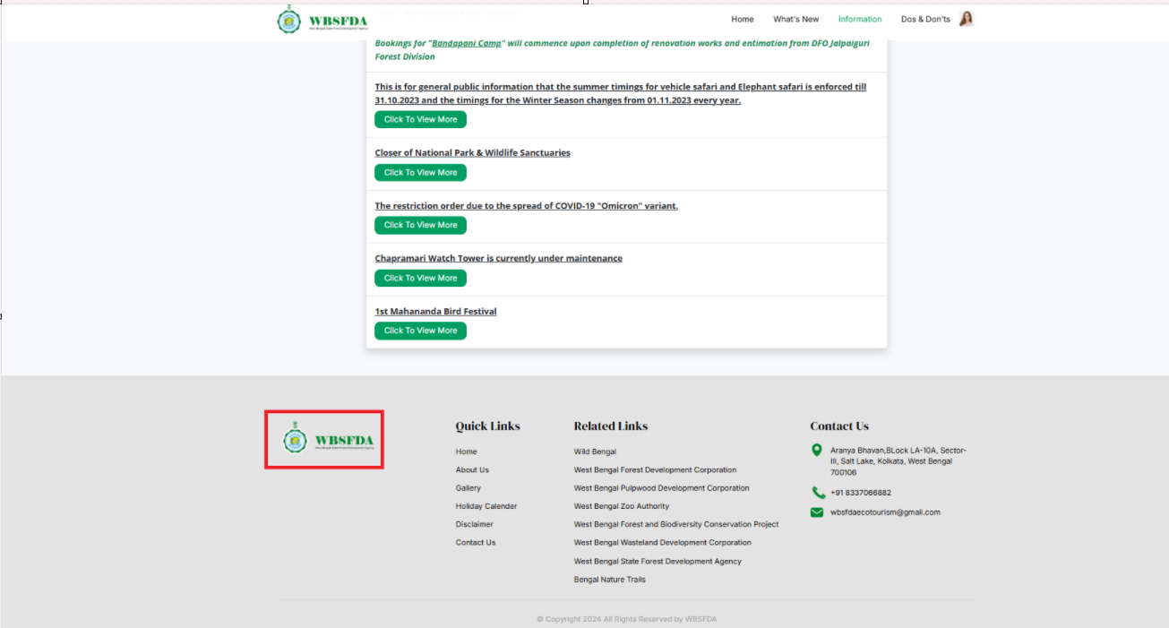

- In Add Visitor Details, if a person is under 18 years old, the dropdown for selecting card type should not show the options for:

1. Voter ID
2. Driving License

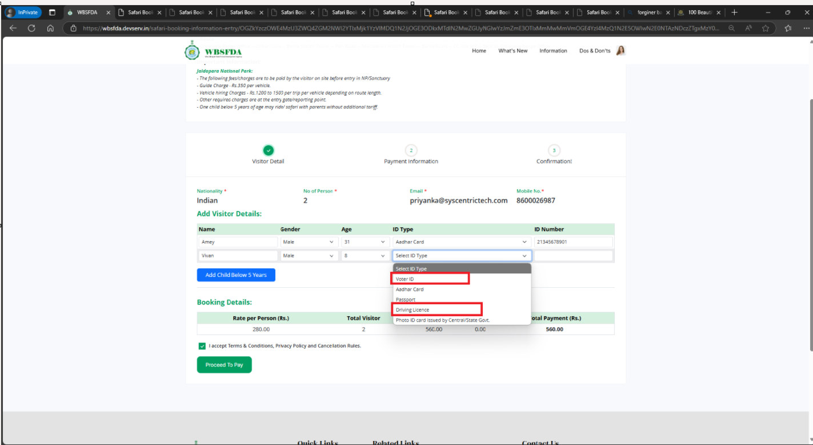

- In Add Visitor Details, the ID number should not be accept any format.

- The ticket was booked after the ticket sale pricing period had closed.

Doubt

**- How many children are allowed with the couple(1-4 years).**